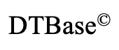**Design & Technology**

**Performance characteristics of materials**

**Materials required for questions**

* Pencil
* Rubber
* Calculator

**Instructions**

* Use black ink or ball-point pen
* Try answer all questions
* Use the space provided to answer questions
* 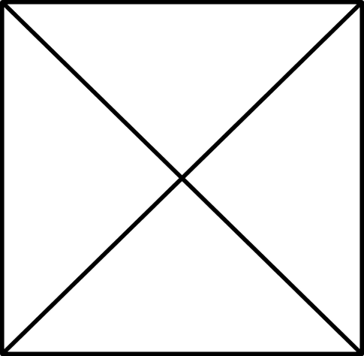Calculators can be used if necessary
* Use a cross in the box to mark you answer

**Advice**

* Marks for each question are in brackets
* Read each question fully
* Try to answer every question
* Don’t spend too much time on one question

**Good luck!**

**Q1.** What word describes a material that can be drawn out into long thin wires?

**A** Malleable

**B** Ductile

**C** Brittle

**Q2.** What is a unique property of shape memory alloy (SMA)?

**A** Resistant to spectacle damage

**B** Flexible

**C** Lightweight

**Q3.** What property describes the ability of a material to withstand sudden and shock loading without fracturing.

**A** Toughness

**B** Hardness

**C** Malleability

**Q4.** A material that resists abrasive wear and indentation has which one of the following properties?

**A** Elasticity

**B** Plasticity

**C** Hardness

**Q5.** Shear strength is defined as:

**A** The ability of a material to return to its

original shape once a deforming force

is removed

**B** The ability of a material or joint to

withstand being pulled apart

**C** The ability of a material to withstand

being squashed

**Q6.** Which one of the following is not a property of mild steel?

**A** Malleable

**B** Tough

**C** Plasticity

**Q7.** A tough material is commonly described as:

**A** A material that can withstand repeated

impacts

**B** A material that is hard to scratch

**C** A material that takes a long time to

decompose

**Q8.** Which of the statements below is the definition of the physical property ‘Elasticity’?

**A** The ability of a material to stand up to

forces being applied without it bending,

breaking, shattering or deforming

**B** The ability of a material to absorb force

and flex in different directions, returning

to its original position

**C** The ability of a material to stretch without

breaking or snapping

**Q9.** Describe two characteristics of metal foams, that make them more suitable than solid sections, in the manufacture of some products/components **(2 marks)**

Property 1:

Property 2:

**Q10**. List two advantages and two disadvantages of materials that are biodegradable? **(4 marks)**

**Q11.** The drawing below shows a pencil sharpener

**(a)** Give **two** properties of carbon steel that make it suitable for the blade of a pencil sharpener **(2 marks)**

**(b)** Describe **one** reason why carbon steel is a better choice of metal for the blade rather than aluminium **(2 marks)**

**ANSWERS NEED SORTING OUT**

**Answers**

**Q1**. B

**Q2**. A

**Q3**. A

**Q4**. C

**Q5**. B

**Q6**. C

**Q7**. A

**Q8**. B

Q9.

Answers could include:

* Lightweight in comparison to solid form
* Low conductivity,
* Compressive strength
* Absorption of a force

Q10.

Handle:

* Steel tube has malleable characteristics that allow it to be curved into handle shape
* High strength to help resist forces from all directions (push/pull)

Side:

* Aluminium tube is lightweight reducing weight of trolley
* High strength to hold handle firmly at chosen length

Strengthening piece:

* Solid steel section to support structure of trolley
* Very tough to absorb impact of force without fracture

Shelf:

* High strength capable of holding heavy weights without flexing/breaking
* Lightweight due to its pressed shape

Q11

Advantages:

* Reduction on Carbon cycle/emissions
* Eco friendly, won’t damage environment
* Renewable materials help with sustainability

Disadvantages:

* More expensive to produce this type of material
* Need for composters, biodegradable materials require specific conditions to decompose

Q12a.

Any **two** properties given from:

* Hard
* Ductile
* Malleable
* Toughness

b. **One** reason described from:

* Carbon steel is harder, which means its wears better/lasts longer
* Carbon steel can have an edge ground on it, which means it will be able to cut/shave/sharpen the pencil
* Carbon steel can be hardened, unlike aluminium which can only be work hardened/alloyed